2025
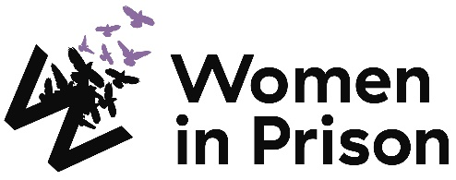

Advocate (Bridges to Health)

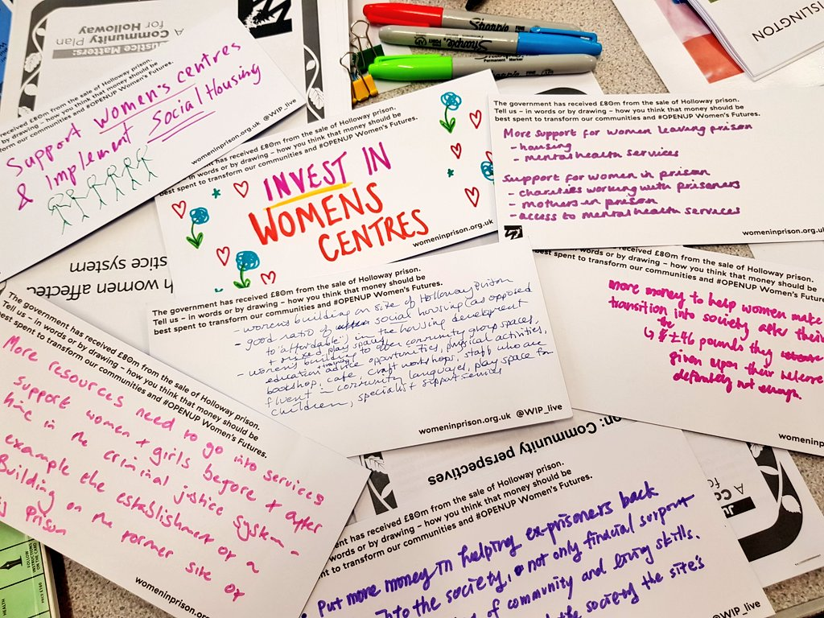

Charity no: 1118727. Company no: 5581944.



Welcome!
Dear Applicant,
Women in Prison is the only national charity focused on women in the criminal justice sector, we are women-led and know the importance of ensuring we have a clear gendered approach in all that we do. Our influencing potential and campaigning voice are substantial. We are currently in our 40th year of supporting women impacted by the criminal justice system. We work with women who are at risk of, or being, harmed by the systems that are meant to protect us.

At Women in Prison we are passionate, ambitious and grounded in the reality of women’s lives. We are proud of our roots as a feminist grassroots organisation, and we have grown from strength to strength since the 1980s, delivering services to women and campaigning for change. We exist to support women facing multiple marginalisation and exclusion, who have been let down, and their rights denied. We believe that prison doesn’t work and we want to see an end to the harmful imprisonment of women in England and Wales.
This is a very exciting time in Women in Prison. As a deeply value-led organisation, we know that our recently agreed set of values represents the unique nature of our organisation, and also need to hold us to account for how we work in an unpredictable future. Our new vision and purpose will guide us as we build a strategy during 2024 to be implemented from 2025.

We know we want to build more coproduction; deeper support to women who are disproportionately affected by the system through an intersectional lens; greater connection between the women we support and the influencing we do; an increased focus on alternatives to the system and a stronger focus on preventing women being caught up in the system.

If you are excited by our purpose, and the breadth of what this role could offer to you, we would love to hear from you.

I look forward to meeting you.


Sonya Ruparel, Chief Executive
Our Story

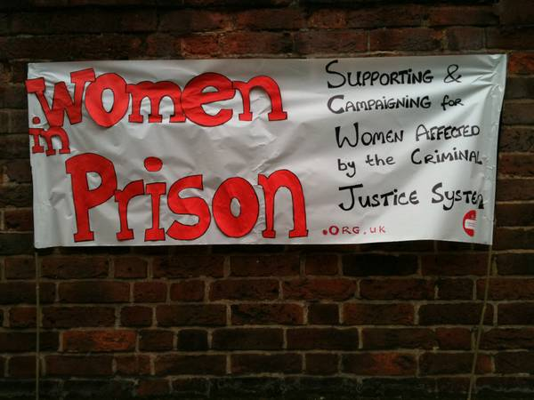

Our Vision is of a society which no longer accepts the structural inequalities that lead women and girls into contact with the criminal justice system.

Women in Prison was born out of the anger our founder – Chris Tchaikovsky – felt about what she experienced and saw when imprisoned in HMP Holloway in the 1980s.

During Chris' time in prison, a woman died after setting fire to her own cell. Chris saw that the specific needs of women in prison and the damaging effect prison sentences were having on women scarcely figured in public or political discourse. So, in 1983, alongside international criminologist Pat Carlen, Chris founded Women in Prison, pushed hard to expose this scandal and campaigned for change. Our founders wanted to increase awareness of the lives behind the women in our prisons, and the impact of poverty and abuse on women’s lives.

Chris believed the idea of sending a woman to prison as punishment was shameful and absurd.

In her words:

“Taking the most hurt people out of society and punishing them in order to teach them how to live within society is, at best, futile. Whatever else a prisoner knows, she knows everything there is to know about punishment because that is exactly what she has grown up with. Whether it is childhood sexual abuse, indifference, neglect; punishment is most familiar to her.”

In the early 1990s, the organisation was able to expand its remit beyond campaigning to deliver direct support to women affected by the criminal justice system. WIP's initial focus on prison in-reach services was then expanded to support women in the community following their release. Chris, sadly, passed away in 2002. Despite the loss of our visionary founder, Women in Prison works to carry on Chris' legacy.

Today, WIP is a national charity dedicated to making a difference to the lives of women affected by the criminal justice system. We campaign for a new system of justice - one that addresses the root causes of offending (including homelessness, substance use, mental ill health and experiences of poverty, trauma and abuse). Our women’s centres in Manchester and London and the services we provide in communities and prisons deliver holistic, women-centred support to enable those whom we work with to address the complex challenges they face.

We want to persuade decision-makers to radically reduce the women’s prison population, by demonstrating how a focus on human rights, social justice, health and investment in specialist community support services, including women’s centres, enables women to move forward with their lives. We do this by:

- Leading inspiring, passionate campaigns to replace the current system, and to radically reduce the number of women in prison, thereby freeing resources for investment in community support services, including women’s centres.
- Delivering high quality, trauma-informed, independent advocacy services for women, in communities and prisons, which focuses on early intervention, health and holistic provision as part of a ‘whole system’ multi-agency response.
- Offering a platform for women’s voices which builds women’s confidence and self-belief, strengthening an understanding of their rights and responsibilities, and provides opportunities to speak ‘truth to power’ to bring about real change

Here is a link to our most recent annual report: 2023_Annual_report__and_accounts_Women_In_Prison.pdf (womeninprison.org.uk)

Advocate (Bridges to Health)
Reports to: Bridges to Health Manager

Direct reports: N/A

About Women in Prison

Women in Prison is a national, women-led, feminist organisation. We deliver front line support to women harmed by the criminal justice system, through our work in prisons, in the community and ‘through the prison gate’ as they resettle back into their communities. We also campaign for systems change that addresses the root causes of offending, reduces the harmful impact of prison, and creates workable, community-based alternatives to imprisonment.
Job Description:
Job Purpose:
Women in Prison’s Advocates deliver high-quality, trauma-informed, independent advocacy for women in communities and in prisons, which focuses on early intervention, and holistic provision as part of a ‘whole system’ multi-agency response that looks to address the root causes of women’s offending.
The primary purpose of this role is to provide in-depth, ongoing support to a caseload of women who have been referred for support by prison staff, predominately the Mental Health In-Reach Teams and Primary Care Teams.

Key Responsibility Areas
- Provide high-quality, trauma-responsive advocacy and support to women in contact with the criminal justice system.
- Maintain case management systems to ensure accurate and timely data recording.
- Develop effective relationships with key stakeholders such as statutory and voluntary sector agencies.

Duties and key responsibilities

Provide high-quality trauma-responsive advocacy and support to women in contact with the criminal justice system.
- Design, coordinate and deliver one to one interventions to women three months prior to their release from prison and for three months in the community, assisting them to achieve their goals.
- Provide a trauma-responsive approach, developing risk and needs assessments and safety plans with women reflecting their individual situation and support needs.
- Ensure that interventions are responsive to and meet the needs of women from diverse and minoritised communities.
- Involve women in the design and delivery of interventions, ensuring that they are at the heart of the work at all times.
- Deliver effective support to women by taking a proactive approach to your personal and professional development, including engaging in relevant internal meetings/forums, attending internal and external training opportunities, engaging in clinical and management supervision and practicing self-care and work boundaries.
- You may be required to develop and deliver workshops around health and wellbeing themes to women based in the prison.

Maintain case management systems to ensure accurate and timely data recording.
- Accurately document all client and professional interactions on both case management database working in line with Women in Prison case management policies at all times.
- Work in line with Data Protection legislation.

Develop effective relationships with key stakeholders such as statutory and voluntary sector agencies.
- Take a collaborative multi-agency approach to supporting women whilst representing the core values of Women in Prison at all times, including representing and supporting women at multi-agency meetings and advocating for their statutory rights.
- Be responsible for establishing and maintain professional relationship and effective communication with mental health and healthcare teams, prison colleagues, and other relevant statutory and voluntary sector agencies.
- Promote a culture of understanding women’s needs and the root cause of women’s offending.
- Ensure that relevant partners are aware of the range of services offered by Women in Prison.

Person Specification:
Skills and Experiences
- Understanding of trauma-informed approaches.
- Good knowledge of the issues faced by women affected by the criminal justice system.
- Good understanding of the impact of complex trauma and intersectionality on women needs, behaviour, health and outcomes.
- Understanding the root cause of women’s offending and the importance of women-specific provision.
- The ability to engage and motivate clients working with a strengths-based approach.
- Dealing with agencies that provide support around benefits, homelessness and housing, mental health, physical health, offending and substance misuse.
- Problem-solve difficult situations and deal with them calmly and effectively.
- Self-motivated with confidence to work alone but can also work co-operatively and flexibly as part of a team.
- Ability to prioritise and manage own time and workload.
- Effective communication skills verbally and in writing with people of many different backgrounds and within a range of settings.
- IT skills at a level that supports report writing, email, Outlook calendar, Teams/Zoom, internet, use of a databases and meticulous case recording in a timely manner in line with WIP’s policies.
- Ability to manage multiple demands while ensuring timely completion of case reports.
- Up to date understanding of safeguarding practice, policy and procedures.

Personal attributes and other requirements
- Commitment to the core values and ethos of Women in Prison, including social justice and feminism.
- Commitment to anti-discriminatory practice and equal opportunities and an ability to apply awareness of diversity issues to all areas of work.
- You will spend around 50% of your week at HMP Send (Ripley Rd, Ripley, Woking GU23 7LJ) and the rest of your week travelling around London and the South East of England to outreach appointments and partnership offices.
- Level 1 Prison Vetting is desirable but not essential.

Notes
This post is subject to the Rehabilitation of Offenders Act (Exceptions Order) 1975. Due to the nature of our work, it will be necessary for an enhanced disclosure to be made to the Disclosure and Barring Service for details of any previous criminal convictions which are not protected under the Act.

The job description does not form part of your contract of employment and can be amended from time to time as the needs of the organisation require.

Terms and Conditions:
Start date: To be confirmed

Salary: £30,640 per annum (inclusive of £3,990 London/Southeast Weighting)

Location: HMP Send (Ripley Road)

Working hours: Full time – 35 hours

Contract: Permanent

Annual leave: 30 days plus statutory bank holidays (if full time). All WIP staff also receive an additional 3 days leave between Christmas and New Year.

Pension scheme: WIP provides an auto enrolment pension scheme with 5% contributions from the employer and 3% from the employee.

Clinical supervision: Working with WIP can be enormously rewarding but also challenging at times. So we provide clinical supervision through a Harley Street practice, to encourage reflective practice and support the wellbeing of our team.

Employee Assistance Programme: Confidential access to a range of support and information on a 24/7 basis. Including legal advice, emotional support, practical advice and signposting.

Cycle to Work Scheme: Eligible employees can save money and spread the cost of a new bike and accessories.

To Apply:

Applications close: 31st October 2025
Interviews with Women in Prison: To be confirmed
To apply: Submit a completed application form to application portal

If you require reasonable adjustments to support you during the application process, please contact the HR team on hr@wipuk.org.
We are happy to invest in developing the right person, so you are welcome to apply even if your professional experience does not fully meet the job description or person specification.

We particularly encourage applications from Black, Asian and minoritised women, and women who have personal experience of the criminal justice system.

In line with legal requirements and the nature of our work, this role:
- Is restricted to women only as a genuine occupational requirement
- Requires the right to work in the UK
- Is subject to an Enhanced + Adult Barred List DBS
- Is subject to HM Prison and Probation Service vetting (‘Enhanced Level 1’ or ‘Standard Plus’)
- Requires that the post holder is not automatically disqualified by (or can obtain a waiver from) the Charity Commission

Equality, Diversity and Inclusion Policy

Our Principle Commitments
WIP is committed to building and valuing diverse teams and taking positive action to promote equality and challenge unfair and unlawful discrimination. We recognise that women may experience multiple and intersecting forms of discrimination based on their sex and additional, real or perceived, characteristics including age, disability, gender reassignment, marriage or civil partnership, pregnancy or maternity, race, religion, sexual orientation, social-economic background, immigration status, caring responsibilities, spent convictions or trade union membership.

WIP works to tackle discrimination and the structural inequalities women experience. We are committed to embedding diversity and inclusion in all areas of our work, including recruitment, and aim to reflect the diversity and excellence of the women that we work with. We actively encourage applications from women from a variety of backgrounds, and with a range of skills and experiences. We are particularly interested to hear from Black, Asian and minoritised women and women who have lived experience of the criminal justice system.

Policy on the Recruitment of Women with Lived Experience of the Criminal Justice System

Women in Prison actively encourages and supports the employment of women with lived experience of the criminal justice system. We believe that women’s own experiences drive the Charity forward through understanding, solidarity and passion for change.

Job Advertisements and the Application Process
We do not ask for disclosure of criminal records during the application process, to ensure that women with lived experience of the criminal justice system are assessed on their merit, without risk of discrimination and are not asked to disclose sensitive personal information unnecessarily.

If a Disclosure and Barring Service (DBS) check is required for a role, this will be stated clearly in the job advert, including the level of DBS.

Levels of DBS Checks
Basic DBS checks contain details of unspent convictions. Standard and Enhanced DBS checks contain details of unspent and spent (unless filtered) convictions and cautions (including reprimands and warnings). Enhanced DBS checks may also include other information held by police forces deemed relevant to the role or check for inclusion on the Children’s or Adults’ Barring List.
Job Offers and the Induction Process
We will only ask for a DBS check at the point of job offer.
Disclosures will be treated confidentially and only stored where necessary, in line with General Data Protection Regulation (GDPR) guidelines. Access will be restricted to limited Senior Management or HR representatives as needed to assess suitability for the role.
A criminal record will not arbitrarily bar women from employment with us. We discuss disclosures with applicants (in person, or via phone or video call), to allow them to explain the background in their own words. We consider the relevance to the role, including the type and seriousness of an offence, how much time has passed and whether the individual’s circumstances have changed. If they have restrictions on the work they are able to do, we consider whether we are able to make reasonable adjustments to facilitate their employment.
The Charity Commission does however have its own automatic disqualification rules on who can hold senior positions within a charity, which apply to our Trustee, CEO and Director of Finance and Resources positions. Although it is possible to apply for a waiver.
Women in Prison does not have a blanket ban on any criminal records and will always approach disclosures fairly and on an individual basis. We seek to balance supporting women with lived experience into employment, alongside safeguarding our current employees, service users and the organisation.

