2025

Collective Project Manager

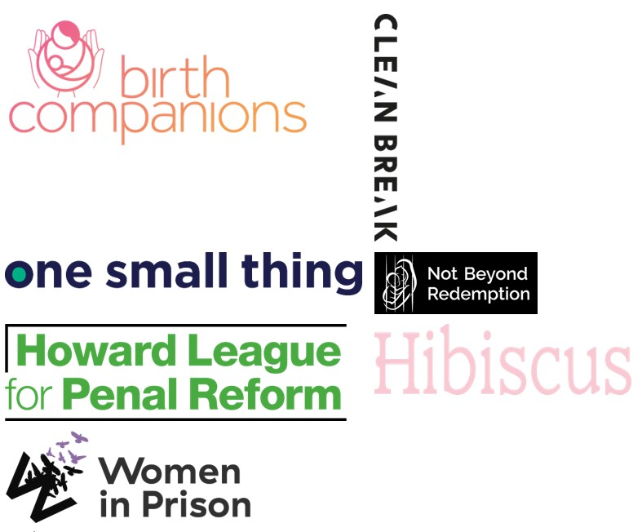

Charity no: 1118727. Company no: 5581944.

Dear applicant,
Thank you for your interest in this unique opportunity.
We are a collective of women-led and justice organisations committed to ending the unjust and unsafe imprisonment of women before they are sentenced or tried in the UK.
Our members include Women in Prison, Hibiscus Initiatives, Howard League for Penal Reform, Clean Break, Birth Companions, One Small Thing and Not Beyond Redemption.
We are backing transformational strategies that aim to end this practice through creative influencing of policy, narrative, and community solutions working with women directly impacted by remand.
We are committed to a coproduced and intersectional approach, which includes involving women with direct experience of remand in our programmes and oversight, and centering groups who are disproportionately impacted, particularly Black and Global Majority women*. We believe their leadership and insight is vital in achieving the impact we want to see.
We care about sharing power, equity, creativity, openness and co-leadership – these are our feminist organising principles.
This role will play an important part in driving forward this ambitious and essential work supporting us to coordinate and deliver on our plans.
If our purpose inspires you and you feel connected to what we are working towards, we would love to hear from you.
We deeply value diversity and the insight that lived experience brings, if you have personal experience of the criminal justice system, we strongly encourage you to apply.
This position is hosted by Women in Prison and will work across the collective to equally support the members.
The End Remand Collective Partners – funded by the Firebird Collective

*Black and Global Majority women who are defined as Black, Asian and minoritised ethnic women from the Global south (includes the continents of Africa, Asian, Latin America, the Caribbean, islands of the Pacific).

Our Story

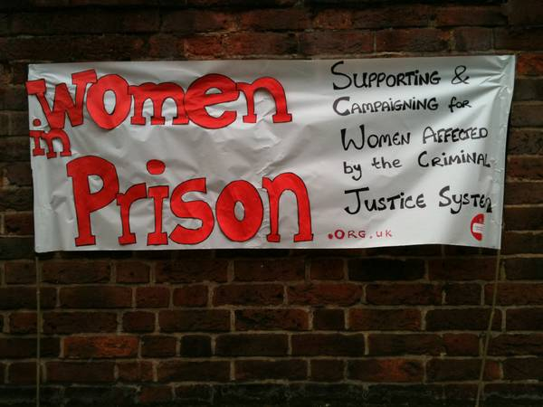

Our Vision is of a society which no longer accepts the structural inequalities that lead women and girls into contact with the criminal justice system.

Women in Prison was born out of the anger our founder – Chris Tchaikovsky – felt about what she experienced and saw when imprisoned in HMP Holloway in the 1980s.

During Chris' time in prison, a woman died after setting fire to her own cell. Chris saw that the specific needs of women in prison and the damaging effect prison sentences were having on women scarcely figured in public or political discourse. So, in 1983, alongside international criminologist Pat Carlen, Chris founded Women in Prison, pushed hard to expose this scandal and campaigned for change. Our founders wanted to increase awareness of the lives behind the women in our prisons, and the impact of poverty and abuse on women’s lives.

Chris believed the idea of sending a woman to prison as punishment was shameful and absurd.

In her words:

“Taking the most hurt people out of society and punishing them in order to teach them how to live within society is, at best, futile. Whatever else a prisoner knows, she knows everything there is to know about punishment because that is exactly what she has grown up with. Whether it is childhood sexual abuse, indifference, neglect; punishment is most familiar to her.”

In the early 1990s, the organisation was able to expand its remit beyond campaigning to deliver direct support to women affected by the criminal justice system. WIP's initial focus on prison in-reach services was then expanded to support women in the community following their release. Chris, sadly, passed away in 2002. Despite the loss of our visionary founder, Women in Prison works to carry on Chris' legacy.

Today, WIP is a national charity dedicated to making a difference to the lives of women affected by the criminal justice system. We campaign for a new system of justice - one that addresses the root causes of offending (including homelessness, substance use, mental ill health and experiences of poverty, trauma and abuse). Our women’s centres in Manchester and London and the services we provide in communities and prisons deliver holistic, women-centred support to enable those whom we work with to address the complex challenges they face.

We want to persuade decision-makers to radically reduce the women’s prison population, by demonstrating how a focus on human rights, social justice, health and investment in specialist community support services, including women’s centres, enables women to move forward with their lives. We do this by:

- Leading inspiring, passionate campaigns to replace the current system, and to radically reduce the number of women in prison, thereby freeing resources for investment in community support services, including women’s centres.
- Delivering high quality, trauma-informed, independent advocacy services for women, in communities and prisons, which focuses on early intervention, health and holistic provision as part of a ‘whole system’ multi-agency response.
- Offering a platform for women’s voices which builds women’s confidence and self-belief, strengthening an understanding of their rights and responsibilities, and provides opportunities to speak ‘truth to power’ to bring about real change

Collective Project Manager

Terms and Conditions:
Location: Can be remote or based in London or Manchester. Must be able to regularly attend all day meetings in London and to travel extensively in England
Reports to: Head of Practice - Women in Prison – Kate Fraser
Position Type: Part time – 3 days a week
Contract: 12-month initial term with a view to extending
Salary: £25029 per annum, actual salary (Full Time Equivalent £41705)
If based in London, £27423 per annum, actual salary (Full Time Equivalent £45705, inclusive of London weighting)

Pension: Aviva Stakeholder pension with a 5% employer contribution
Annual leave: April to March - 30 days plus statutory bank holidays (18 days + pro-rated bank holidays for a 3-day week) we also have an additional 3 closure days between Christmas and New Year.
Other benefits: Eye-care vouchers, Cycle to Work Scheme, Employee discount platform, Clinical Supervision and Employee Assistance Programme.
About this project
Remand harms women. It separates them from their children, can mean they lose their home and jobs, and it can mean poorer health outcomes for women, including if they are pregnant.
Here’s what women on Remand told Women in Prison about their experience, and about the impact of remand on their lives:
“When we arrived, no information given, prison pack, no information. The feeling of no control and you don’t know what happened” “[The impact of remand is] losing everything and distant contact with kids. I feel like I’m losing everything because when I get out, I have to start again.”
“I have a child with separation anxiety who struggles without me. This is causing dysfunctional families. My child is autistic, so they need me, and there are loads of autistic women in here that are not getting the right support...”
“99% of us are treated like dogs, I did not have my meds for three days and this fell on deaf ears. I had to kick and scream, the person I dealt with was rude, but when I kick off, I get penalized...
“Unless it’s a case of murder or attempted murder I don’t think women should be in prison, babies should not be separated from their mother, if this was me that would lead me to suicide. My neighbour has a drinking problem, and she got done for arson, when she fell asleep smoking and things caught on fire, rather they should have gotten her help with rehab. They should also take into account special needs.”
“I’m not getting adequate nutrition from the food here. I’m in the first trimester of pregnancy and my tummy has been really unsettled. I have other children in the care of family.”
We are a collective of women-led and justice organisations who care deeply about ending the unjust, unsafe, and unfair use of remand (imprisonment before trial or whilst awaiting a sentence) against women in the UK.
The use of remand against women is rising, accounting for a quarter of all women in prison. It is deeply harmful and unnecessary: many women will go on to be found not guilty or serve a community sentence; many are separated from their children and dependents; up to a quarter of self-harm incidents in women’s prisons involve women on remand; many will lose their support networks, jobs and homes; and Black and Global Majority women are disproportionately impacted.
This practice must stop - we are building a project of influencing work to end its overuse and misuse, co-produced with women impacted by remand. This work is initially supported by the Firebird Collective.
Role Summary:
We are building something bold: a collective of women and organisations working side by side to end the unjust, unsafe and unfair use of remand against women in the UK. We need a leader who is not only strategic and organised, but also deeply committed to the power of lived experience, coproduction, and intersectional feminist principles.
This role is the backbone of the project. You’ll hold the threads that connect our members, supporting and championing women with lived experience of the criminal justice system, and ensure our collective voice is strong, united, and impactful. You’ll be guiding—not dictating—so that the project grows from the wisdom, creativity, and resilience of the women at its heart.
If you’re ready to use your skills and passion to create real change, and you believe in leadership that listens, collaborates and disrupts the injustice of remand, this is the role for you.
Women with lived experience are actively encouraged to apply for this role, if you do not think you meet all the criteria set out below but do believe you have transferable skills or relevant experience that would make you successful in this role, we would be happy to have an informal conversation with you, to arrange this, please contact Kate Frasier katie.frasier@wipuk.org

Role Specification:
Key Responsibilities:
- Project management and coordination
- Coordination of the collective
- Partnerships and stakeholder engagement
- Communication
Project management and coordination:
- Work with the collective to design and deliver an ambitious plan rooted in our Theory of Change
- Ensure the project’s plans and ways of working always reflect our coproduction charter
- Support and connect workstream leads, ensuring activities align and learning is captured, shared, and celebrated
- Hold space for change and adaptability: this project evolves with the women who shape it and the shifting political landscape
- Support the accountability committee with workplans, budgets, strategy, and risk analysis
- Set up and facilitate collective meetings, workshops and trainings, making sure everyone’s voice is heard and respected
- Keep strong systems in place for communication, collaboration and shared decision making
- Lead on core project admin: scheduling, record keeping, data management, and logistics
- All other project management tasks that are necessary for coordination of the project
Partnerships and stakeholder engagement
- Support the collective to work together constructively, resolving differences and strengthening relationships
- Represent the project at key events and support collective members in their own external engagement
- Build and maintain close links Firebird as the principal funder and key partner and support ongoing fundraising initiatives
- Welcome and onboard additional partners ensuring equal voice and active participation
- Codesign and deliver joint events and meetings with external stakeholders
- Travel to member organisations across England to stay connected with their work
Communication
- Develop clear, accessible reporting structures for funders, partners and women with lived experience with support from Firebird
- Prepare and present reports and updates for diverse audiences
- Keep the project’s website and other platforms updated and engaging
- Work with Firebird to track and report on budgets

Person Specification (Skills/Qualifications):
Essential
- Strong project management/organisational skills
- Experience working with a wide range of stakeholders
- Skilled at writing clear, compelling reports
- Excellent communication and facilitation skills, with the ability to hold inclusive spaces
- Comfortable working with budgets and financial information
- Experience of working in social justice and a clear understanding of feminist, anti-racist and intersectional practices
Desirable
- Communications experience
- Understanding of the criminal justice system and how it affects women through lived, learned or professional experience
- Experience working with funders/donors

To Apply:

Applications close: Friday, 24th October at 9am
First interviews: week of 3rd November
Final interviews: week of 10th November
To apply: Please upload your CV and your answers to the shortlisting questions to application portal

We will be shortlisting candidates based on their responses to the following 4 questions; please answer each with a maximum of 250 words per question.

- What interests you about this role, and how do your past experiences make you a good fit for it?
- Can you tell us about your experience in managing projects? Please include details like the size of the projects, the industry you worked in, and any tools you used to help with project management.
- How do you incorporate values of anti-racism, feminism, and intersectionality into your professional work?
- Can you provide an example of a time when you worked with a group of people or stakeholders, making sure everyone felt included and valued?

If you require reasonable adjustments to support you during the application process, please contact the HR team on hr@wipuk.org. If you would like to discuss anything related to the role itself, please contact Kate Fraser mailto:katie.fraser@wipuk.org
We are happy to invest in developing the right person, so you are welcome to apply even if your professional experience does not fully meet the job description or person specification.

We particularly encourage applications from Black, Asian and minoritised women, and women who have personal experience of the criminal justice system.

If you do have lived experience, please see policy below on the Recruitment of Women with Lived Experience of the Criminal Justice System.

In line with legal requirements and the nature of our work, this role:
- Is restricted to women only as a genuine occupational requirement
- Requires the right to work in the UK
- Is subject to a basic DBS check.

Equality, Diversity and Inclusion Policy

Our Principle Commitments
WIP is committed to building and valuing diverse teams and taking positive action to promote equality and challenge unfair and unlawful discrimination. We recognise that women may experience multiple and intersecting forms of discrimination based on their sex and additional, real or perceived, characteristics including age, disability, gender reassignment, marriage or civil partnership, pregnancy or maternity, race, religion, sexual orientation, social-economic background, immigration status, caring responsibilities, spent convictions or trade union membership.

WIP works to tackle discrimination and the structural inequalities women experience. We are committed to embedding diversity and inclusion in all areas of our work, including recruitment, and aim to reflect the diversity and excellence of the women that we work with. We actively encourage applications from women from a variety of backgrounds, and with a range of skills and experiences. We are particularly interested to hear from Black, Asian and minoritised women and women who have lived experience of the criminal justice system.

Policy on the Recruitment of Women with Lived Experience of the Criminal Justice System

Women in Prison actively encourages and supports the employment of women with lived experience of the criminal justice system. We believe that women’s own experiences drive the Charity forward through understanding, solidarity and passion for change.

Job Advertisements and the Application Process
We do not ask for disclosure of criminal records during the application process, to ensure that women with lived experience of the criminal justice system are assessed on their merit, without risk of discrimination and are not asked to disclose sensitive personal information unnecessarily.

If a Disclosure and Barring Service (DBS) check is required for a role, this will be stated clearly in the job advert, including the level of DBS.

HM Prison and Probation Service (HMPPS) vetting (if a role requirement)
If HMPPS vetting is required for a role, this will be stated in the advert. Women in Prison has to adhere to this vetting requirement in order to deliver some of its services. We actively encourage and support women with lived experience to apply for our roles, but it should be noted that vetting must be passed to be appointed to roles with this requirement; there is no comprehensive list of reasons why vetting may be failed, though there is evidence to suggest that vetting may be failed for the following reasons: -

- Offenses against vulnerable people
- Offenses motivated by hate or discrimination
- Domestic abuse offenses
- Murder
- Firearms offenses
- Dishonesty-related offenses, such as fraud
- Multiple offenses
- Offenses involving violence, drugs, or dishonesty

Failure to disclose information
You might fail vetting if you don't disclose information about yourself or people close to you that raise concerns with the Police.

Incomplete or incorrect information
You might fail vetting if you provide incomplete or incorrect information on your application.
The level of checks you undergo will depend on the role you're applying for and the type of access you'll have. You'll need to provide supporting documentation to confirm your identity address, and right to work

Unlock can provide you with some guidance on applying for roles in the criminal justice sector.

Levels of DBS Checks
Basic DBS checks contain details of unspent convictions. Standard and Enhanced DBS checks contain details of unspent and spent (unless filtered) convictions and cautions (including reprimands and warnings). Enhanced DBS checks may also include other information held by police forces deemed relevant to the role or check for inclusion on the Children’s or Adults’ Barring List.
Job Offers and the Induction Process
We will only ask for a DBS check at the point of job offer.
Disclosures will be treated confidentially and only stored where necessary, in line with General Data Protection Regulation (GDPR) guidelines. Access will be restricted to limited Senior Management or HR representatives as needed to assess suitability for the role.
A criminal record will not arbitrarily bar women from employment with us. We discuss disclosures with applicants (in person, or via phone or video call), to allow them to explain the background in their own words. We consider the relevance to the role, including the type and seriousness of an offence, how much time has passed and whether the individual’s circumstances have changed. If they have restrictions on the work they are able to do, we consider whether we are able to make reasonable adjustments to facilitate their employment.
The Charity Commission does however have its own automatic disqualification rules on who can hold senior positions within a charity, which apply to our Trustee, CEO and Director of Finance and Resources positions. Although it is possible to apply for a waiver.
Women in Prison does not have a blanket ban on any criminal records and will always approach disclosures fairly and on an individual basis. We seek to balance supporting women with lived experience into employment, alongside safeguarding our current employees, service users and the organisation.

Thank you for your interest

